**EXERCISE-1**

**Create a simple HTML page using basic tags.**

**Code: -**

**<!DOCTYPE html>**

**<html>**

**<head>**

**<title>using html tags</title>**

**</head>**

**<body>**

**<p><i>hello world**! </i><br>

<u>hello world! </u><br>

<b>hello world! </b><br>

</p>

</body>

</html>

OUTPUT: -

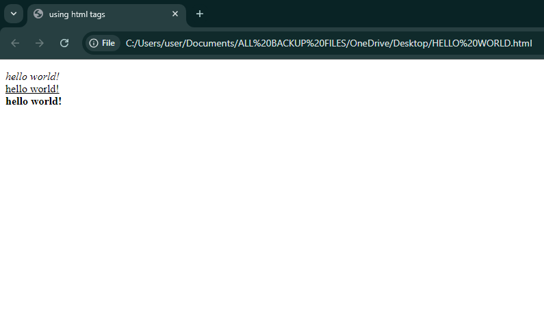

EXERCISE-2

Create a web page that displays your name to the screen.

**Code: -**

**<!DOCTYPE html>**

**<html>**

**<head>**

**<title>displaying my name</title>**

**</head>**

**<body>**

**<b>AMBUJ YADAV</b>**

**</body>**

**</html>**

**OUTPUT: -**

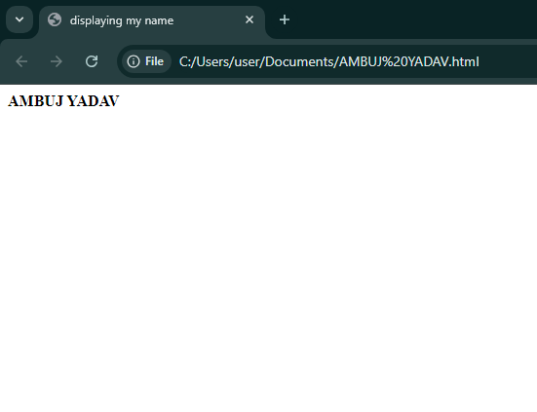

**EXERCISE-3**

**Create a web page and show the output from 1 to 10 in separate lines.**

**Code: -**

**<!DOCTYPE html>**

**<html>**

**<head>**

**<title>Numbers in Separate lines</title>**

**</head>**

**<body>**

**1<br>2<br>3<br>4<br>5<br>6<br>7<br>8<br>9<br>10<br>**

**</body>**

**</html>**

**OUTPUT: -**

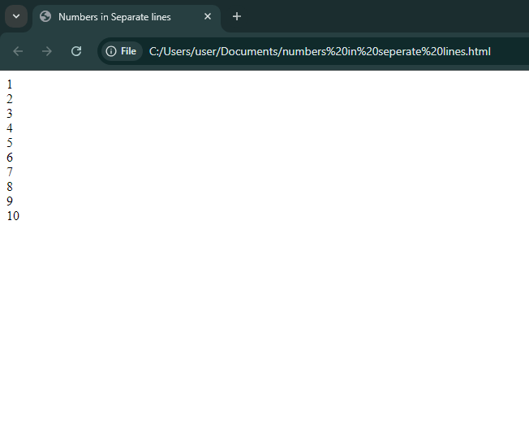

**EXERCISE-4**

**Create a web page and show the output from 1 to 10 in separate lines, each number being in different color.**

**Code: -**

**<!DOCTYPE html>**

**<html>**

**<head>**

**<title>using separate color</title>**

**</head>**

**<body>**

**<h1><font color=”blue”>1</h1><h2><font color=”green”>2</h2><h3><font color=”brown”>3</h3><h4><font color=”pink”>4</h4><h5><font color=”grey”></h4><h5><font color=”magenta”></h5><h6><font color=”violet”></h6><h2><font color=”olive”>7</h2><h3><font color=”gold”>8</h3><h4><font color=”yellow”>9</h4><h5><font color=”red”></h5>10<h6><font color=”marron”</h6>**

**</body>**

**</html>**

**OUTPUT: -**

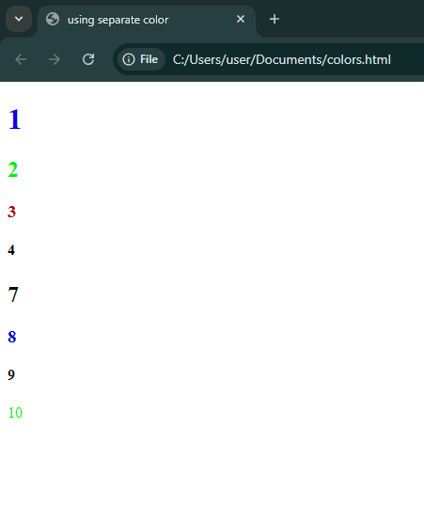

**EXERCISE-5**

**How do I make a picture as a background on my web pages?**

**Code: -**

**<!DOCTYPE html>**

**<html>**

**<head>**

**<title>picture as a background</title>**

**</head>**

**<body>**

**<body background=”**[**https://png.pngtree.com/thumb_back/fh260/background/20200714/pngtree-modern-double-color-futuristic-neon-background-image_351866.jpg**](https://png.pngtree.com/thumb_back/fh260/background/20200714/pngtree-modern-double-color-futuristic-neon-background-image_351866.jpg)**”>**

**</body>**

**</html>**

**OUTPUT: -**

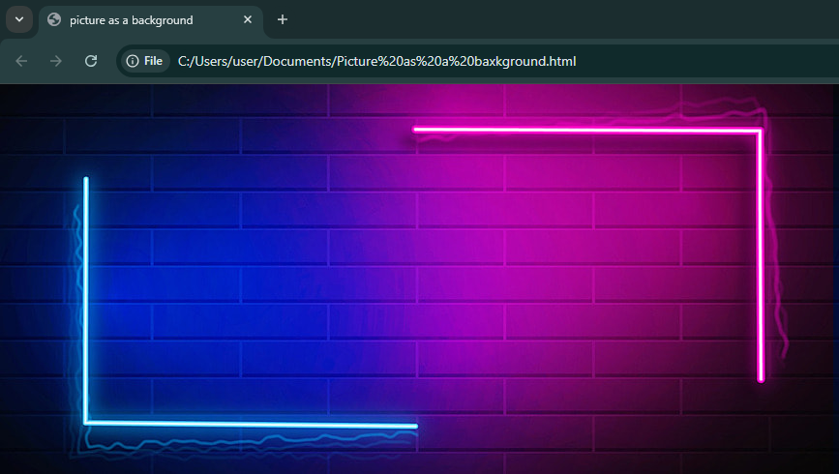

**EXERCISE-6**

**Create a web page to print a paragraph with 4-5 sentences, each sentence shall have a different font.**

**Code: -**

**<!DOCTYPE html>**

**<html>**

**<head>**

**<title>paragraph print</title>**

**</head>**

**<body>**

**<font face=” Algerian”>** Manav Rachna Educational Institutions is a group of 3 higher education institutions and 8 International schools spread across the country. **</font><br>**

**The Manav Rachna International Schools network consists of 8 branches spread across 5 cities - Faridabad, Gurugram, Noida, Mohali and Ludhiana, all of which have garnered positive sentiments in providing CBSE based education.**

**Very recently, Manav Rachna has ventured into offering the IB Curriculum to give a global edge to its commitment of excellence at MRIS. </font>**

**</body>**

**</html>**

**OUTPUT: -**

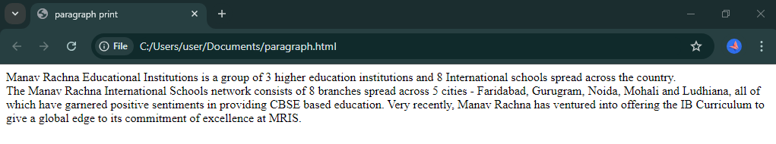

**EXERCISE-7**

**WRITE HTML CODE TO PRINT A PARAGRAPH THAT IS DESCRIPTION OF A BOOK, IT SHALL INCLUDE THE TITLE OF THE BOOK, ITS AUTHOR NAME, NAME AND TITLE SHOULD BE UNDERLINE AND ALL ADJECTIVES SHALL BE BOLD AND ITALICS.**

**Code: -**

**<!DOCTYPE html>**

**<html>**

**<head>**

**<title>about book</title>**

**</head>**

**<body>**

**<dl>**

**<dt><u>HARRY POTTER</u></dt>**

**<dd>Harry Potter is a series of novels by <u>British author J. K. Rowling</u>. The novels follow Harry Potter, an 11-year-old boy who discovers he is the son of <b><i>famous</i></b>wizards and will attend Hogwarts School of Witchcraft and Wizardry. Harry learns of an entire society of wizards and witches. He befriends several Hogwarts students and teachers along his journey. Each novel chronicles one year in Harry's life and his adventures discovering the events that led to his parents' deaths at the hands of Lord Voldemort, a <b><i>dark</i></b>wizard believed<b><i>long</i></b>dead.** **The novels were monumentally<b><i>popular</i></b>, quickly becoming pop culture.**

**Harry Potter characters have become famous even among those who have never read the books. In its first twenty years, the series sold half a billion copies. Their place as literature has also been praised, with many comparing the series to other works like His Dark Materials and the works of Roald Dahl. </dd>**

**</dl>**

**</body>**

**</html>**

**OUTPUT: -**

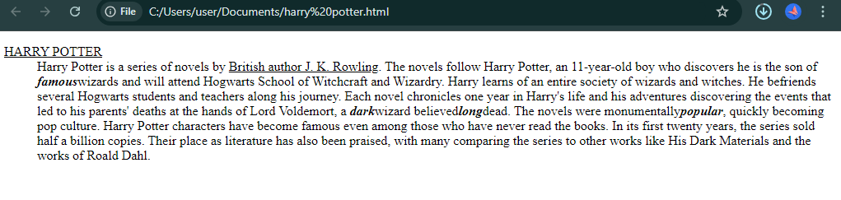

**EXERCISE-8**

**WRITE HTML CODE TO PRINT YOUR NAME USING HEADING TAG, EVERY LETTER SHALL BE OF DIFFERENT HEADING SIZES.**

**CODE: -**

**<!DOCTYPE html>**

**<html>**

**<head>**

**<title>heading tag</title>**

**</head>**

**<body>**

**<h1>A</h1><h2>M</h2><h3>B</h3><h4>U</h4><h5>J</h5><br><h1>Y</h1><h2>A</h2><h3>D</h3><h4>A</h4><h5>V</h5>**

**</body>**

**</html>**

**OUTPUT:-**

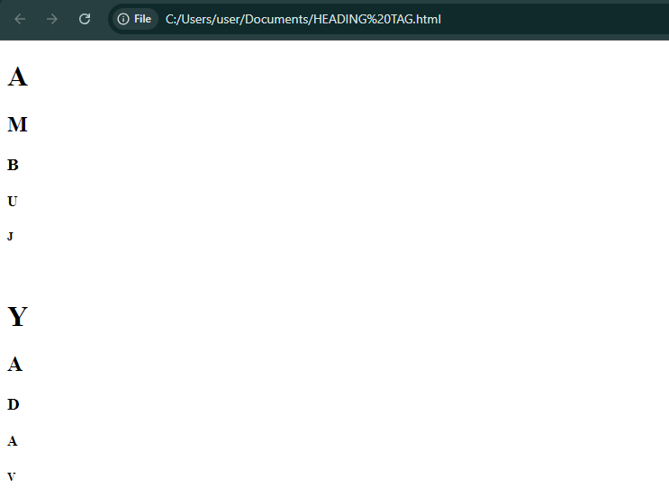

**EXERCISE-9**

**WRITE HTML CODE TO PRINT THE SEQUENCE OF NUMBERS 1-20. EACH NUMBER SHALL BE IN DIFFERENT LINE WITH NUMBER 2 NEXT TO IT AS SUBSCRIPT, AN EQUAL SIGN AND THE RESULT.**

**CODE: -**

**<!DOCTYPE html>**

**<html>**

**<head>**

**<title>subscript</title>**

**</head>**

**<body>**

**1<br>2<sub>1</sub>=2<br>3<sub>2</sub>=4<br>4<sub>3</sub>=8<br>5<sub>4</sub>=16<br>6<sub>5</sub>=32<br>7<sub>6</sub>=64<br>8<sub.7</sub.=85<br>9<sub>8</sub>=87<br>10<sub>9</sub>=102<br>11<sub>10</sub>=112<br>12<sub>11</sub>=212<br>13<sub>12</sub>=312<br>14<sub>13</sub>=412<br>15<sub>14</sub>=482<br>16<sub>15</sub>=666<br>17<sub>16</sub>=777<br>18<sub>17</sub>=795<br>19<sub>18</sub>=800<br>20<sub>19</sub>=888**

**</body>**

**</html>**

**OUTPUT: -**

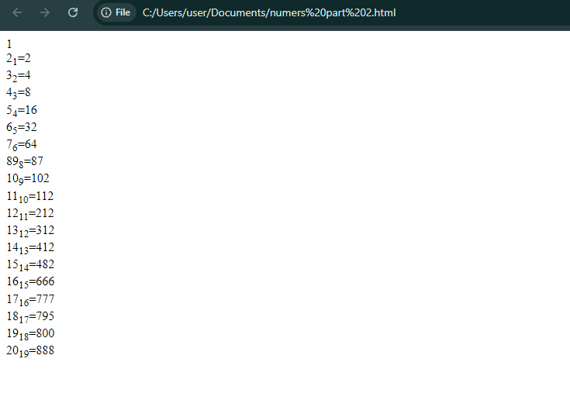

**EXERCISE-10**

**WRITE HTML CODE TO DISPLAY AN IMAGE WITH BORDER OF SIZE WITH WIDTH 200, HEIGHT 200 PIXELS, LEAVING HSPACE AND VSPACE OF YOUR CHOICE WITH IMAGE HANGING IN THE RIGHT SIDE ON THE SCREEN.**

**CODE: -**

**<!DOCTYPE html>**

**<html>**

**<head>**

**<title>hspace vspace</title>**

**</head>**

**<body>**

**<img Src=”https://images5.alphacoders.com/134/thumb-1920-1341498.png"height="200"width="200"hspace="520"vspace="30">**

**<img Src=”https://images5.alphacoders.com/134/thumb-1920-1341498.png"height="200"width="200"hspace="520"vspace="30">**

**</body>**

**</html>**

**OUTPUT: -**

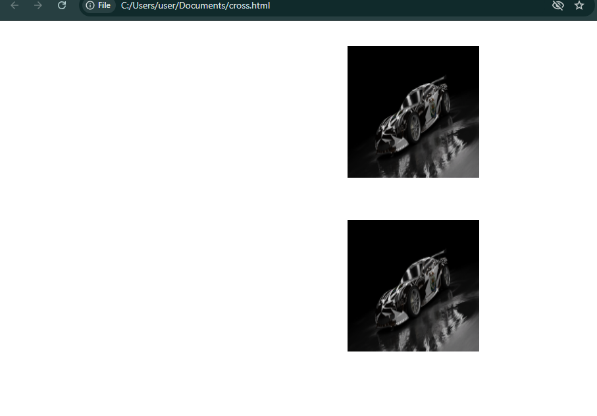

**EXERCISE-11**

Write HTML code to create a web page with heading. The heading shall be displayed at the top-center of the page and the image shall be at the centre, just below the heading.

**<!DOCTYPE html>**

**<html>**

**<head>**

**<title>Simple Web Page</title>**

**<style>**

**body {**

**text-align: center;**

**margin: 0;**

**padding: 20px;**

**font-family: Arial, sans-serif;**

**}**

**h1 {**

**margin: 20px 0;**

**}**

**img {**

**max-width: 100%;**

**height: auto;**

**}**

**</style**

**</head>**

**<body>**

**<h1>SERGEANT CROSS </h1>**

**<img src="** **https://images5.alphacoders.com/134/thumb-1920-1341498.png">**

**</body>**

**</html>**

**OUTPUT: -**

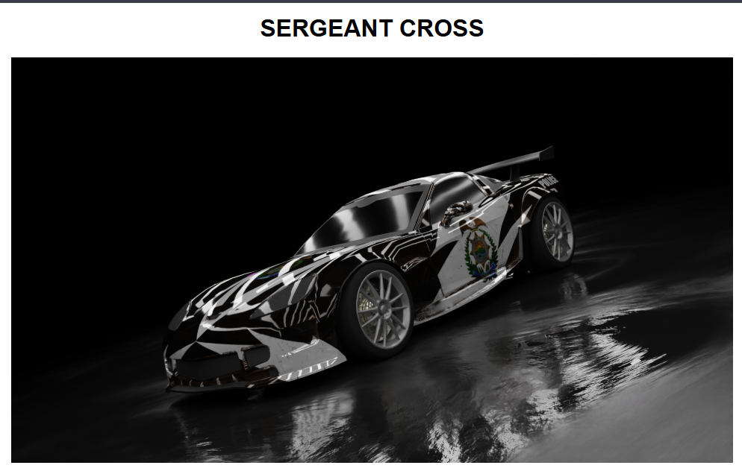

**EXERCISE-12**

Write HTML code using Multimedia tags.

<!DOCTYPE html>

<html>

<head>

<title>Multimedia Page</title>

<style>

body {

text-align: center;

margin: 0;

padding: 20px;

font-family: Arial, sans-serif;

}

</style>

</head>

<body>

<h1>Welcome to My Multimedia Page</h1>

<h2>Audio Player</h2>

<audio src="https://1drv.ms/v/c/e0d0810e2451897d/Ed8aoUPJOpNCgfV4lD4Ot7UBWNp6d7Xdzdz_SzVexAev3Q?e=wYOdNc">

</audio>

<h2>Video Player</h2>

<video width="640" height="360" controls>

<source src="https://muxer.sf-converter.com/get/OXNpV3hwT2VlV018Q2hhbGxlbmdlIE1lISAjMyAtIFtORlNNV10gQUktRHJpdmVuIENyb3NzJyBDb3J2ZXR0ZSB2cy4gUmF6b3J8MTczMjUzMzk4Mw.90dcbe6eaff14a14812436fc40a7aaf4">

</video>

</body>

</html>

**OUTPUT: -**